 

**MIDDLE EAST TECHNICAL UNIVERSITY**

**DEPARTMENT OF ELECTRICAL & ELECTRONICS ENGINEERING**

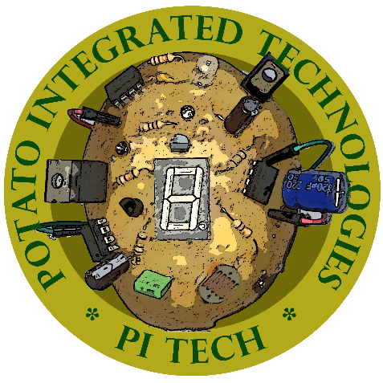

**Potato Integrated Technologies**

**Conceptual Design Report**

**Project: Devices Trying to Score in Each Other’s Goals**

**Duration: 01/10/2018 – 01/06/2019**

**Estimated Cost: $200**

**Design Studio Coordinator: Arzu KOÇ (Section 5)**

|  |  |  |  |  |
| --- | --- | --- | --- | --- |
| **COO**  İrem COŞKUN  2030419  +90 539 414 5969 | **CMO**  Berkay  GÖKSU  2030757  +90 505 635 8145 | **CTO**  Furkan Bahadır  ELİK  2030518  +90 554 963 9410 | **CEO**  Fatma Nur  ARABACI  2030047  +90 533 602 7527 | **CFO**  Aycan  BEYENİR  2030328  +90 539 330 0570 |